1.
Draw a labeled diagram of an ATX motherboard and mark at least 8 different slots and ports (such as RAM slots, PCIe slots, SATA ports, USB headers, CPU socket, power connector, etc.).

Labeled ATX motherboard diagram
Here is a simple ATX motherboard layout showing more than 8 slots/ports:

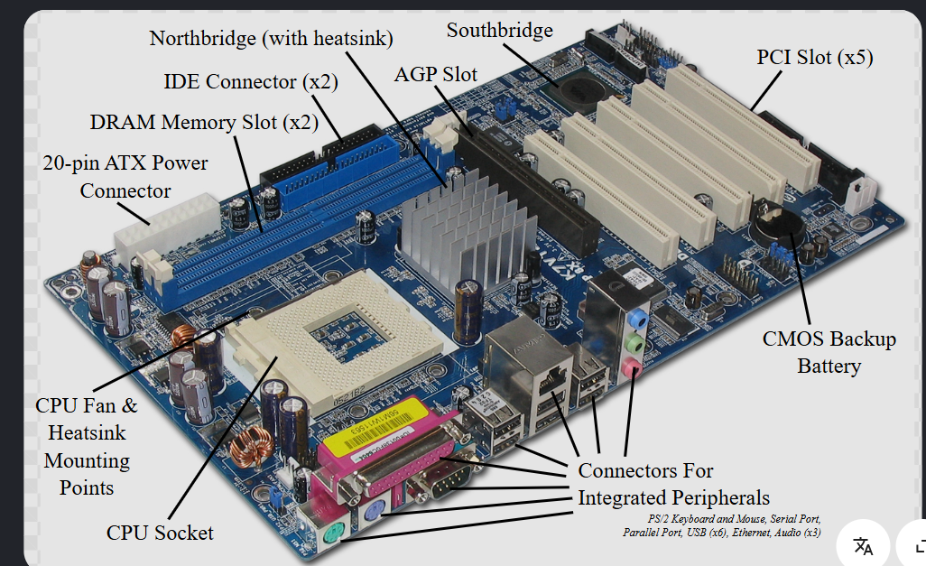

12 parts identified: CPU socket, RAM/DIMM slots, PCIe x16 slot, PCIe x1 slots, M.2 slot, SATA ports, USB headers, 24-pin ATX power connector, CPU power connector, chipset, front-panel header, and rear I/O ports. These are common motherboard components; a typical motherboard reference lists these same categories of connectors and slots.

2.
Research and list 3 popular CPU socket types (for example: LGA1151, AM4, LGA1200) and name one compatible CPU model for each.

Three popular CPU socket types.

CPU socket | Example compatible CPU
LGA1151 | Intel Core i7-9700K
AM4 | AMD Ryzen 5 5600
LGA1200 | Intel Core i5-10600K
Intel's compatibility information confirms that the Core i7-9700K belongs to the LGA1151 family, while Intel's 10th-generation desktop processors use LGA1200. Intel+1 The Ryzen 5 5600 is an AM4 processor.

Important: A CPU socket name alone does not guarantee compatibility. The motherboard chipset and BIOS version can also matter.

3.
Explain in your own words the primary functions of the CPU and the chipset on a motherboard, and describe how they work together when you open a music app like Spotify.

CPU vs. chipset — how they work together

CPU
The CPU (Central Processing Unit) is the computer's main processor. It executes instructions, performs calculations, and controls the processing of programs. Think of it as the computer's main worker/decision-maker.

Chipset
The chipset helps the CPU communicate with and manage various devices connected to the motherboard. It handles or coordinates many input/output functions, such as USB devices, storage connections, and expansion devices. Modern CPUs also contain some functions that older motherboards traditionally handled through separate chips.

Example: opening Spotify
When you open Spotify:
- You click the Spotify icon.
- The CPU executes the instructions needed to start the application.
- The operating system and application need to access data from storage, memory, and other hardware.
- The motherboard's chipset and connected controllers help provide communication between the CPU and various I/O devices.
- The CPU processes Spotify's instructions and manages the application.
- Audio data is transferred through the system to the audio hardware, which sends the sound to your headphones or speakers.
So, in simple terms: the CPU does much of the processing, while the chipset/platform provides important pathways and control for communication with motherboard-connected hardware.

4.
Find a clear photo of a real motherboard (from the internet or your own device), and identify at least 5 different ports or slots by circling them and labeling each one.

Real motherboard photo with identified components

A good real motherboard photograph is shown below. It is particularly useful because the board is photographed from an angle and the major components have already been marked.
On this photograph, you can identify at least these five:
- CPU/Processor socket — large socket near the center-left.
- DIMM/RAM slots — long slots near the top.
- PCIe x16 slot — long expansion slot for devices such as a graphics card.
- SATA ports — connectors along the right edge for SATA storage devices.
- 24-pin ATX power connector — large power connector near the upper-right.
- Chipset — heatsink near the center.
- USB headers — internal connectors along the lower edge.
- Rear I/O ports — USB, audio, network and other ports along the left edge.
The photograph's original annotations identify the CPU socket, DIMM slots, 24-pin power connector, SATA, PCIe slots, USB, network and audio ports.

For the "circle and label" requirement
If your teacher specifically requires circles drawn directly on the photograph, use the displayed photo and add five colored circles around:
- 🔴 CPU socket
- 🔵 RAM/DIMM slots
- 🟢 PCIe x16 slot
- 🟡 SATA ports
- 🟣 24-pin ATX power connector
I can't directly draw those circles onto the internet-sourced image in this chat, but the photograph above gives you a clear real motherboard to annotate.

